|  |
| --- |
|  |

**Sub-task 1:**

* *anz-logo.jpg and bank-card.jpg are two images that show up in the users network traffic.*
* *Extract these images from the pcap file and attach them to your report.*

*Answer*

* I was able to analyze the packet capture file using wireshark, using the search term 'http' to filter for relevant traffic.
* After identifying the anz-logo.jpg, I followed the TCP stream to investigate further, and rebuild them forensically using a hex viewer.
* In order to rebuild the file I will carved out just that file’s hex data, by identfying the file signature for jpeg "FFD8" header and "FFD9" footer.
* I then saved the file as a jpg and opened it, resulting in the image below.
* 
* I followed the same process for the second image.

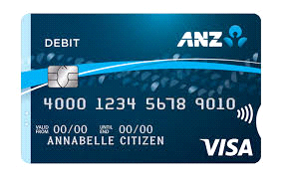

**Sub-task 2:**

* *The network traffic for the images "ANZ1.jpg" and "ANZ2.jpg" is more than it appears.*
* *Extract the images, include them and mention what is different about them in your report.*

*Answer*

Following thesame process of extrcting images as in Sub-task1, after inspecting the TCP stream ANZI1.jpg contained the message "You've found a hidden message in this file! Include it in your write up.".



*ANZ1.jpg*

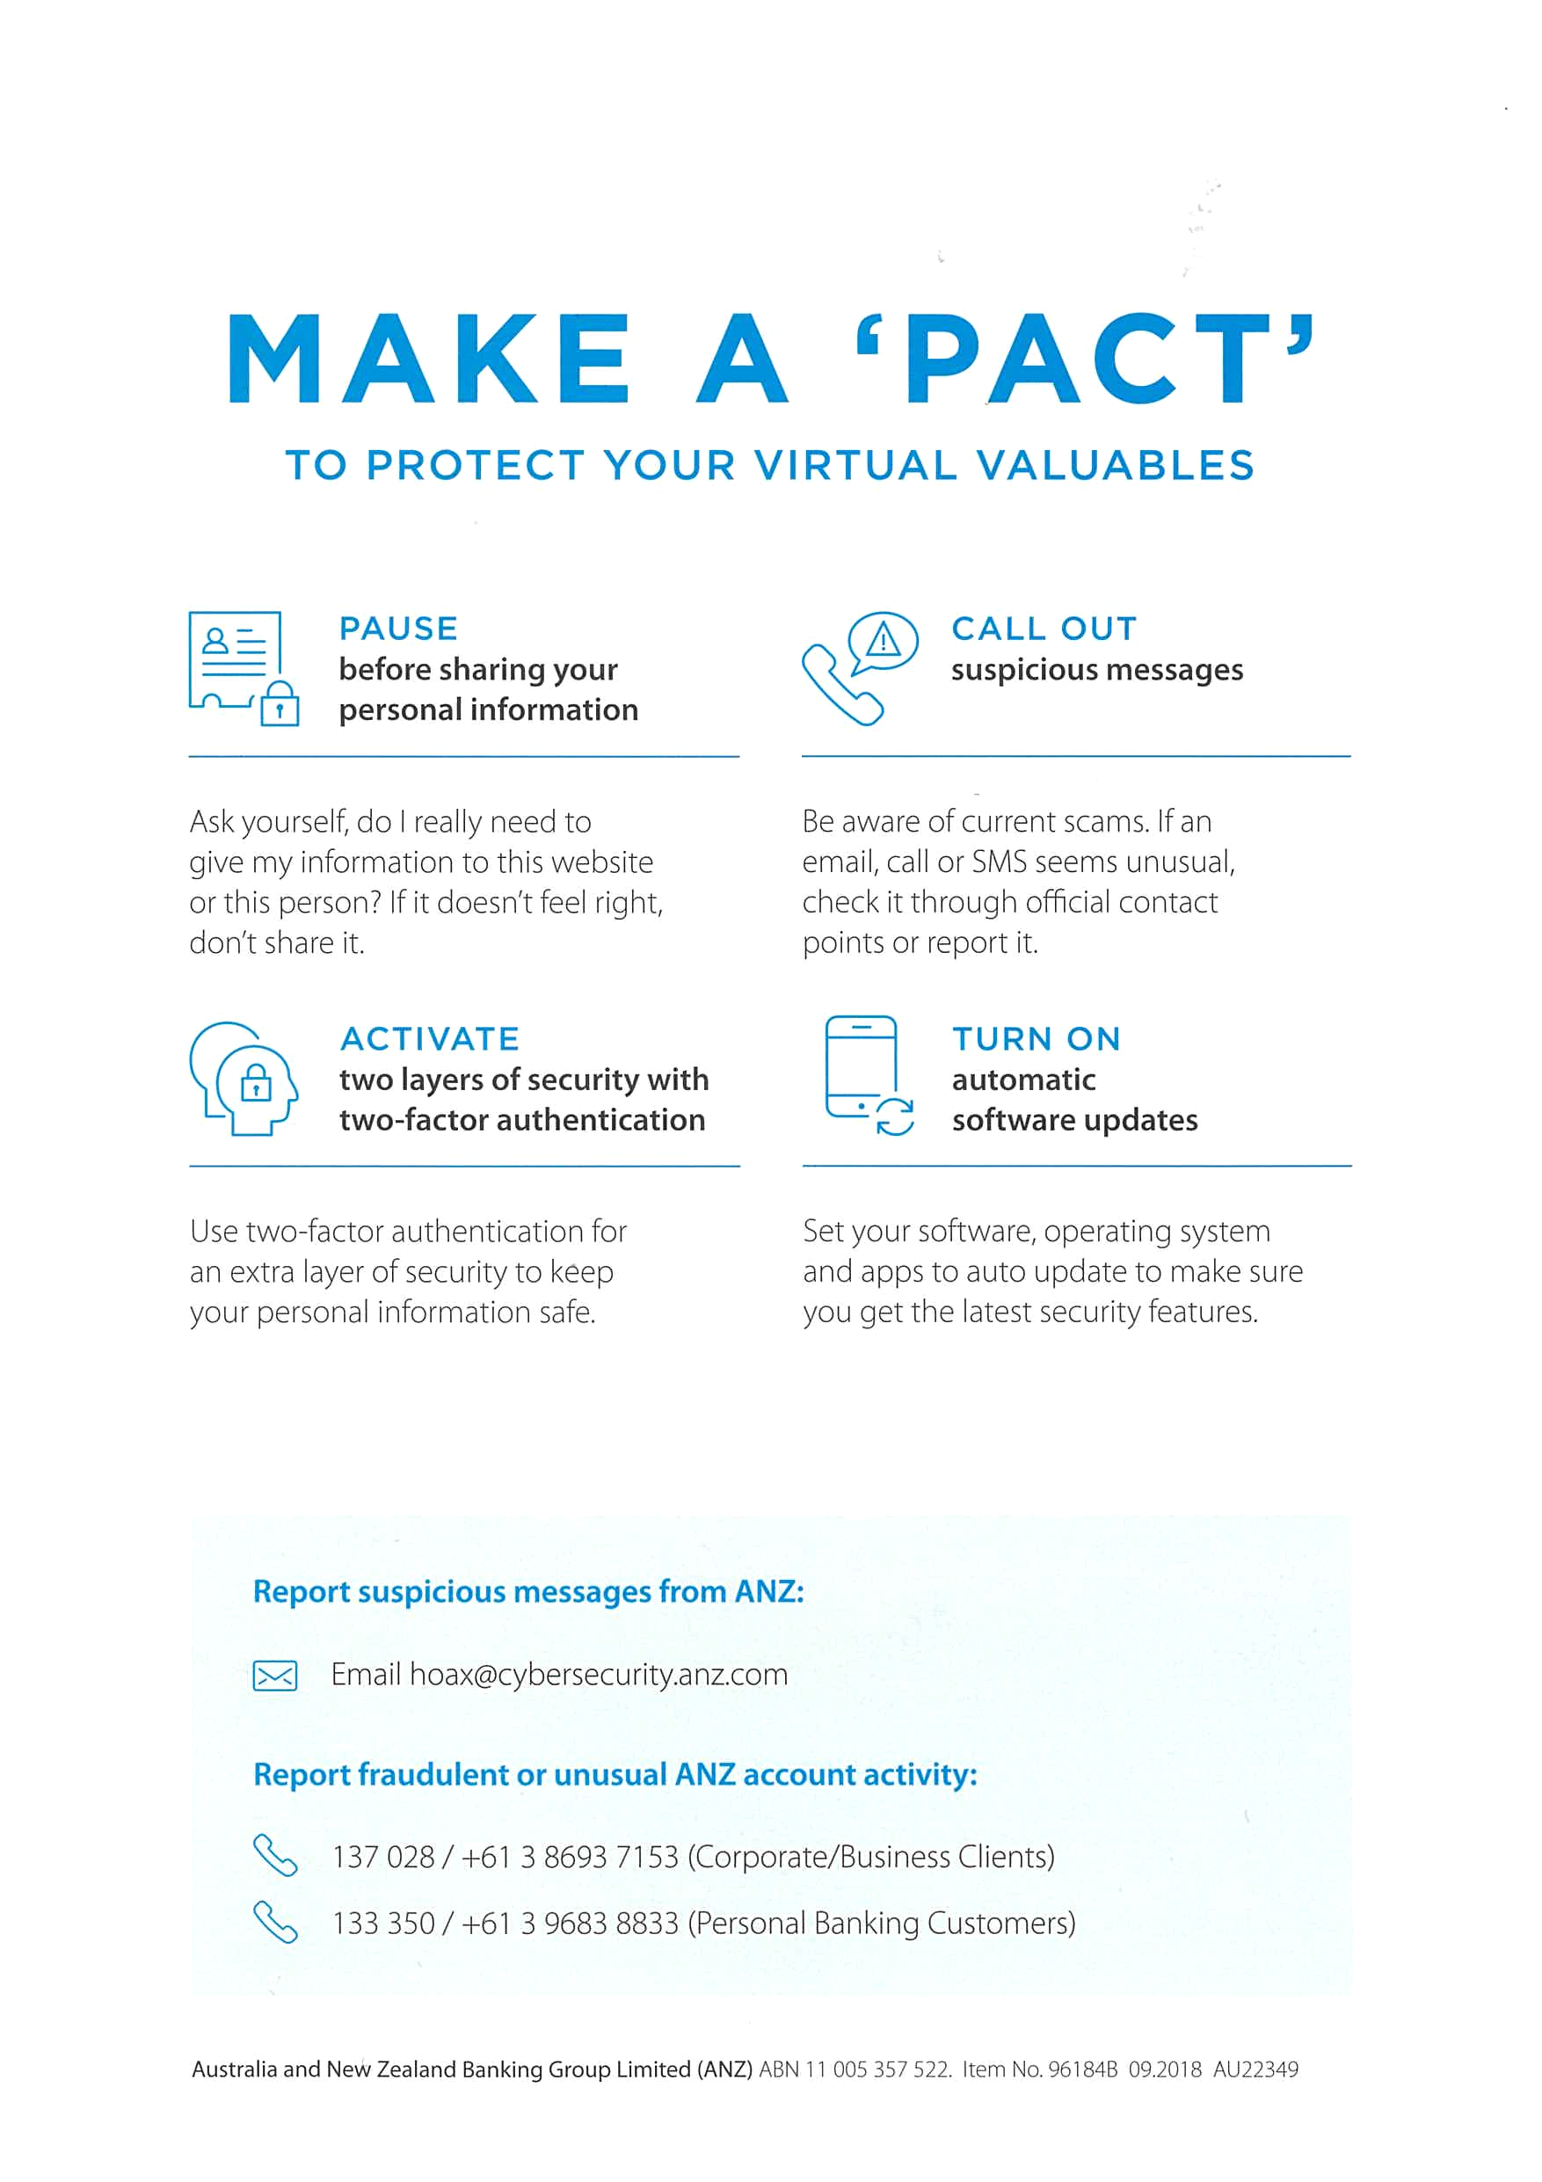

*ANZ2.jpg* contained the message "You've found the hidden message!

Images are sometimes more than they appear."

**Sub-task 3:**

* *The user downloaded a suspicious document called "how-to-commit-crimes.docx"*
* *Find the contents of this file and include it in your report.*

*Answer*

* Following the TCP stream of *how-to-commit-crimes.docx",* I arrived at the ASCII data that showed the content:

Content-Type: application/vnd.openxmlformats-officedocument.wordprocessingml.document

Step 1: Find target

Step 2: Hack them

This is a suspicious document.

**Sub-task 4:**

* *The user accessed 3 pdf documents: ANZ_Document.pdf, ANZ_Document2.pdf, evil.pdf*
* *Extract and view these documents. Include images of them in your report.*

*Answer*

Following the same process of extracting the carving out the file signature for image and rebiulding in hex viewer, the following images were extracted;



ANZ_Document.pdf

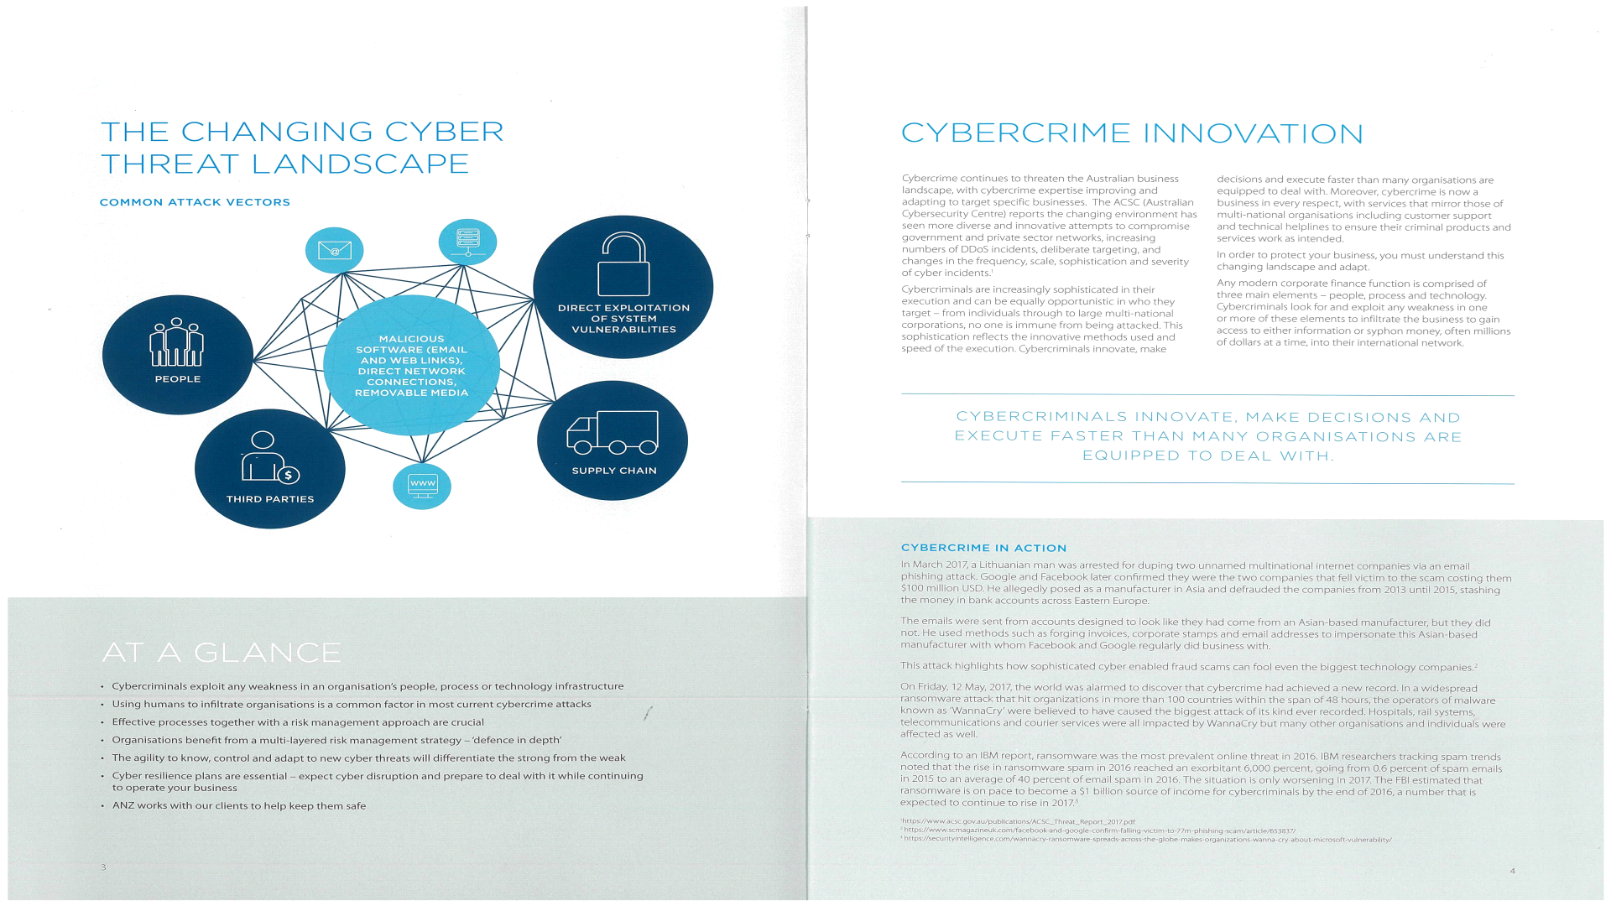

ANZ_Document2.pdf



evil.pdf

**Sub-task 5:**

* *The user also accessed a file called "hiddenmessage2.txt"*
* *What is the contents of this file? Include it in your report*

*Answer*

on examining the tcp stream, I recognised the ASCII string 'JFIF' near the start which indeicates hiddentmessage.txt is a picture file. on extracting the header and footer signatures;



hiddenmessage.txt

**Sub-task 6:**

* *The user accessed an image called "atm-image.jpg"*
* *Identify what is different about this traffic and include everything in your report.*

***Answer***

The picture apperas blurry. It seems some bits are missing from the picture.

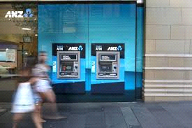

**atm-image.jpeg**

**Sub-task 7:**

* *The network traffic shows that the user accessed the image "broken.png"*
* *Extract and include the image in your report.*

*Answer*

broken.png

**Sub-task 8:**

* *The user accessed one more document called securepdf.pdf*
* *Access this document include an image of the pdf in your report. Detail the steps to access it.*

*Answer*

* After following the TCP stream, I arrived at a PK segment in the stream which indicated a zip file.
* Using hxd editor i open the saved as file from the stream and saved on my desktop as .zip.
* After extracting, I got the following pictures;

